  rofiat.ayagbe@womentechsters.org

Rofiat Ajagbe

Practical activity 4

1.Created file in a home directory called authentic.sh

2.Nano Editor to add code

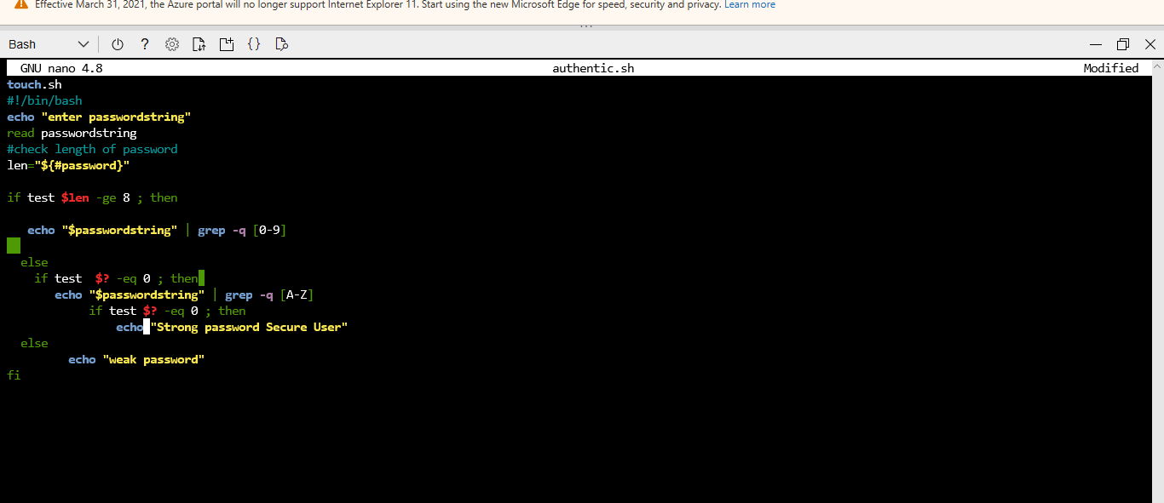

nano authentic.sh

touch authentic .sh

#!/bin/bash

echo "enter passwordstring"

read passwordstring

#check length of password

len="${#password}"

if test $len -ge 8 ; then

echo "$passwordstring" | grep -q [0-9]

else

fi

if test $? -eq 0 ; then

echo "$passwordstring" | grep -q [A-Z]

if test $? -eq 0 ; then

echo "Strong password Secure User"

else

echo "weak password"

fi

3. Screenshots of code

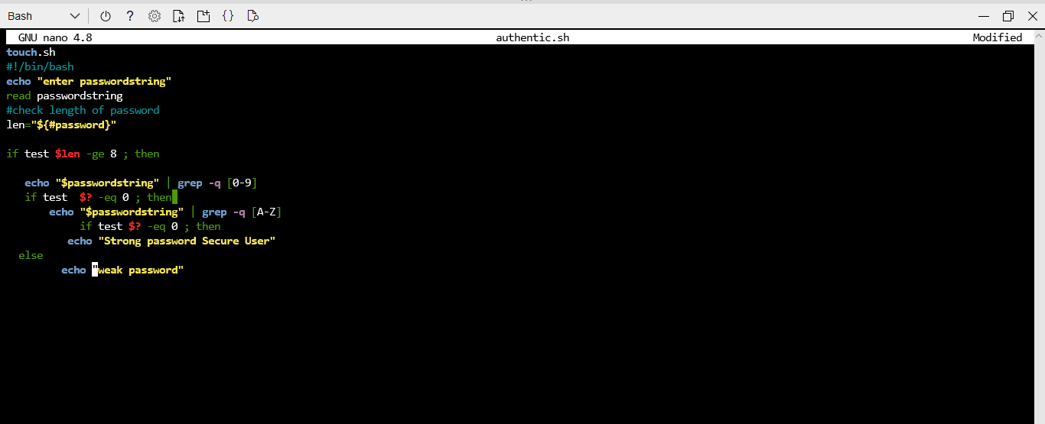

4.screenshot of different password attempts